**1. List of Features**

* First Person
* Game world, including:
  + 3D Objects
  + Characters
  + Weapons
  + Track
  + Arena
* Windows Platform deployed
* Background Story
* Different Game Modes
  + Race
  + Pineapple Payload (hot potato mode)
* Multiplayer
* Audio and sound effects
* Comprehensive/informative HUD
* Menus
* Race tracker
* Timer

**2. Choice of Game Engine**

The game engine chosen for this particular project is the Unity engine. Unity was chose for this project for it’s flexible, yet solid structure that it provides, as well as the fact the entire group has the most experience working with Unity and C# scripting.

**3. Diagrams and System Design**

* Class Hierarchy(who inherits from what)
* Application flow (user centric) - need graph for this
* Stages of Map(how the server handles it)- need graph for this
  + Rules & Mechanics: Racing
  + Rules & Mechanics: Pineapple Payload
* Pawn Interface for external effects (how do we push others and do other things to others)- need graph for this (Ask Walek about Projectile interactions)
  + Powerups
  + Weapons

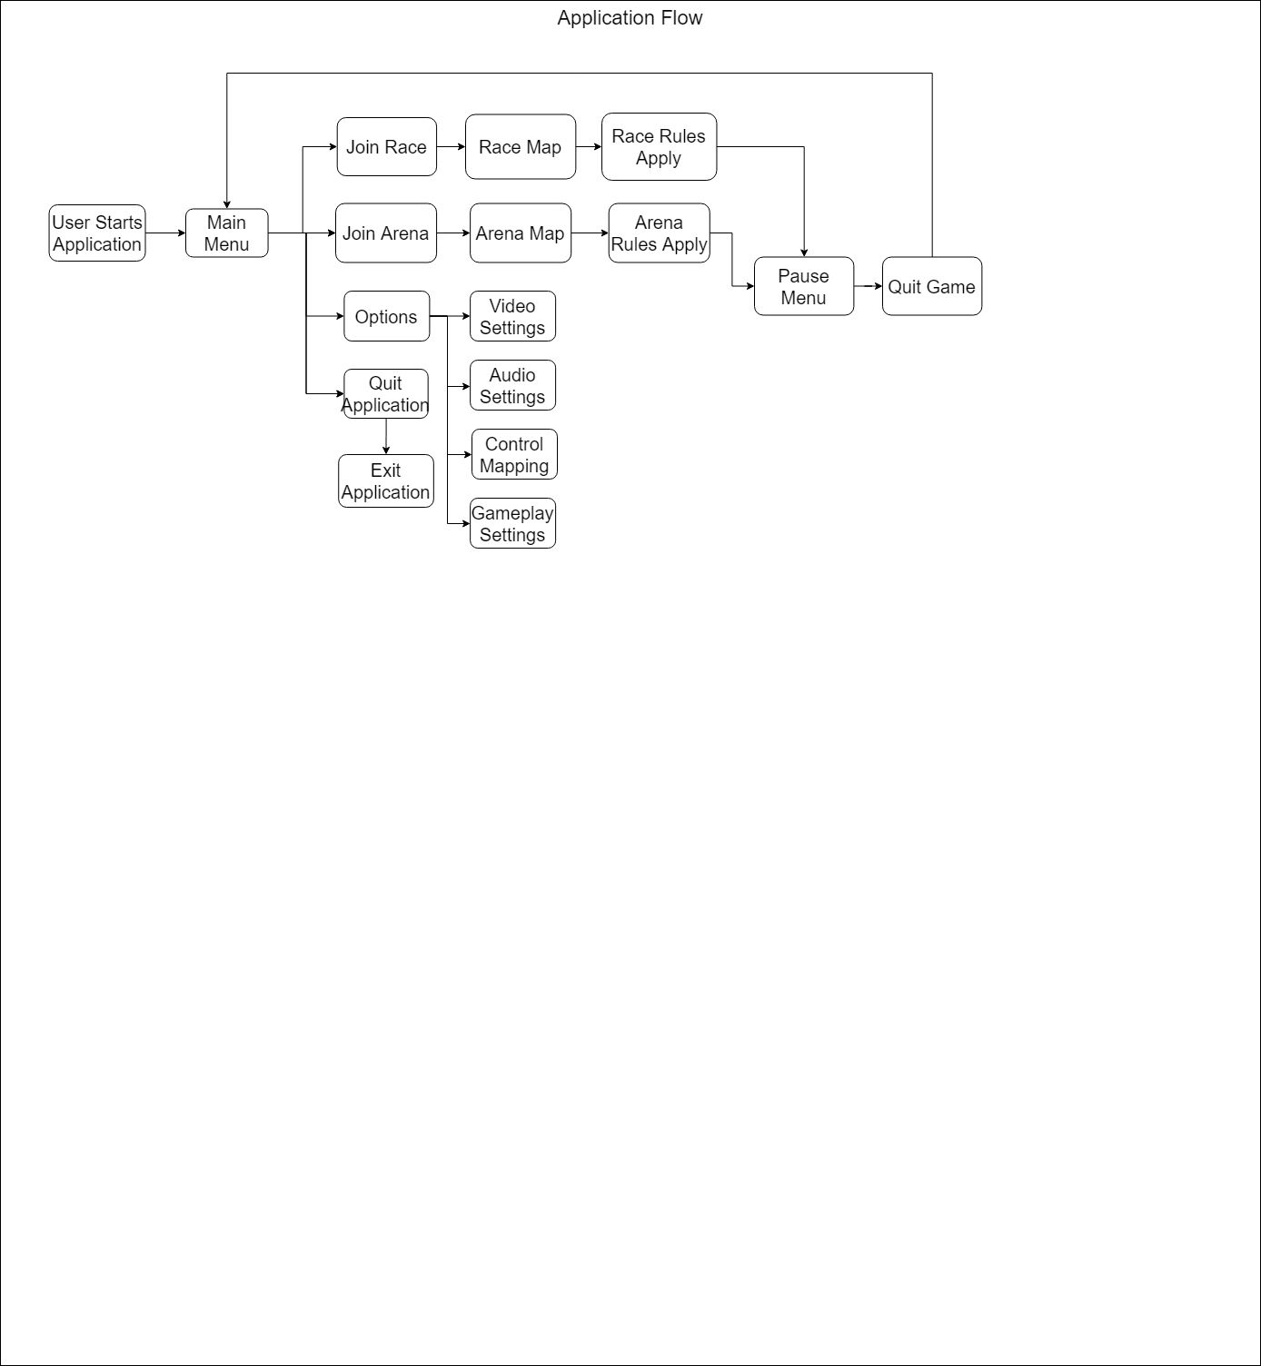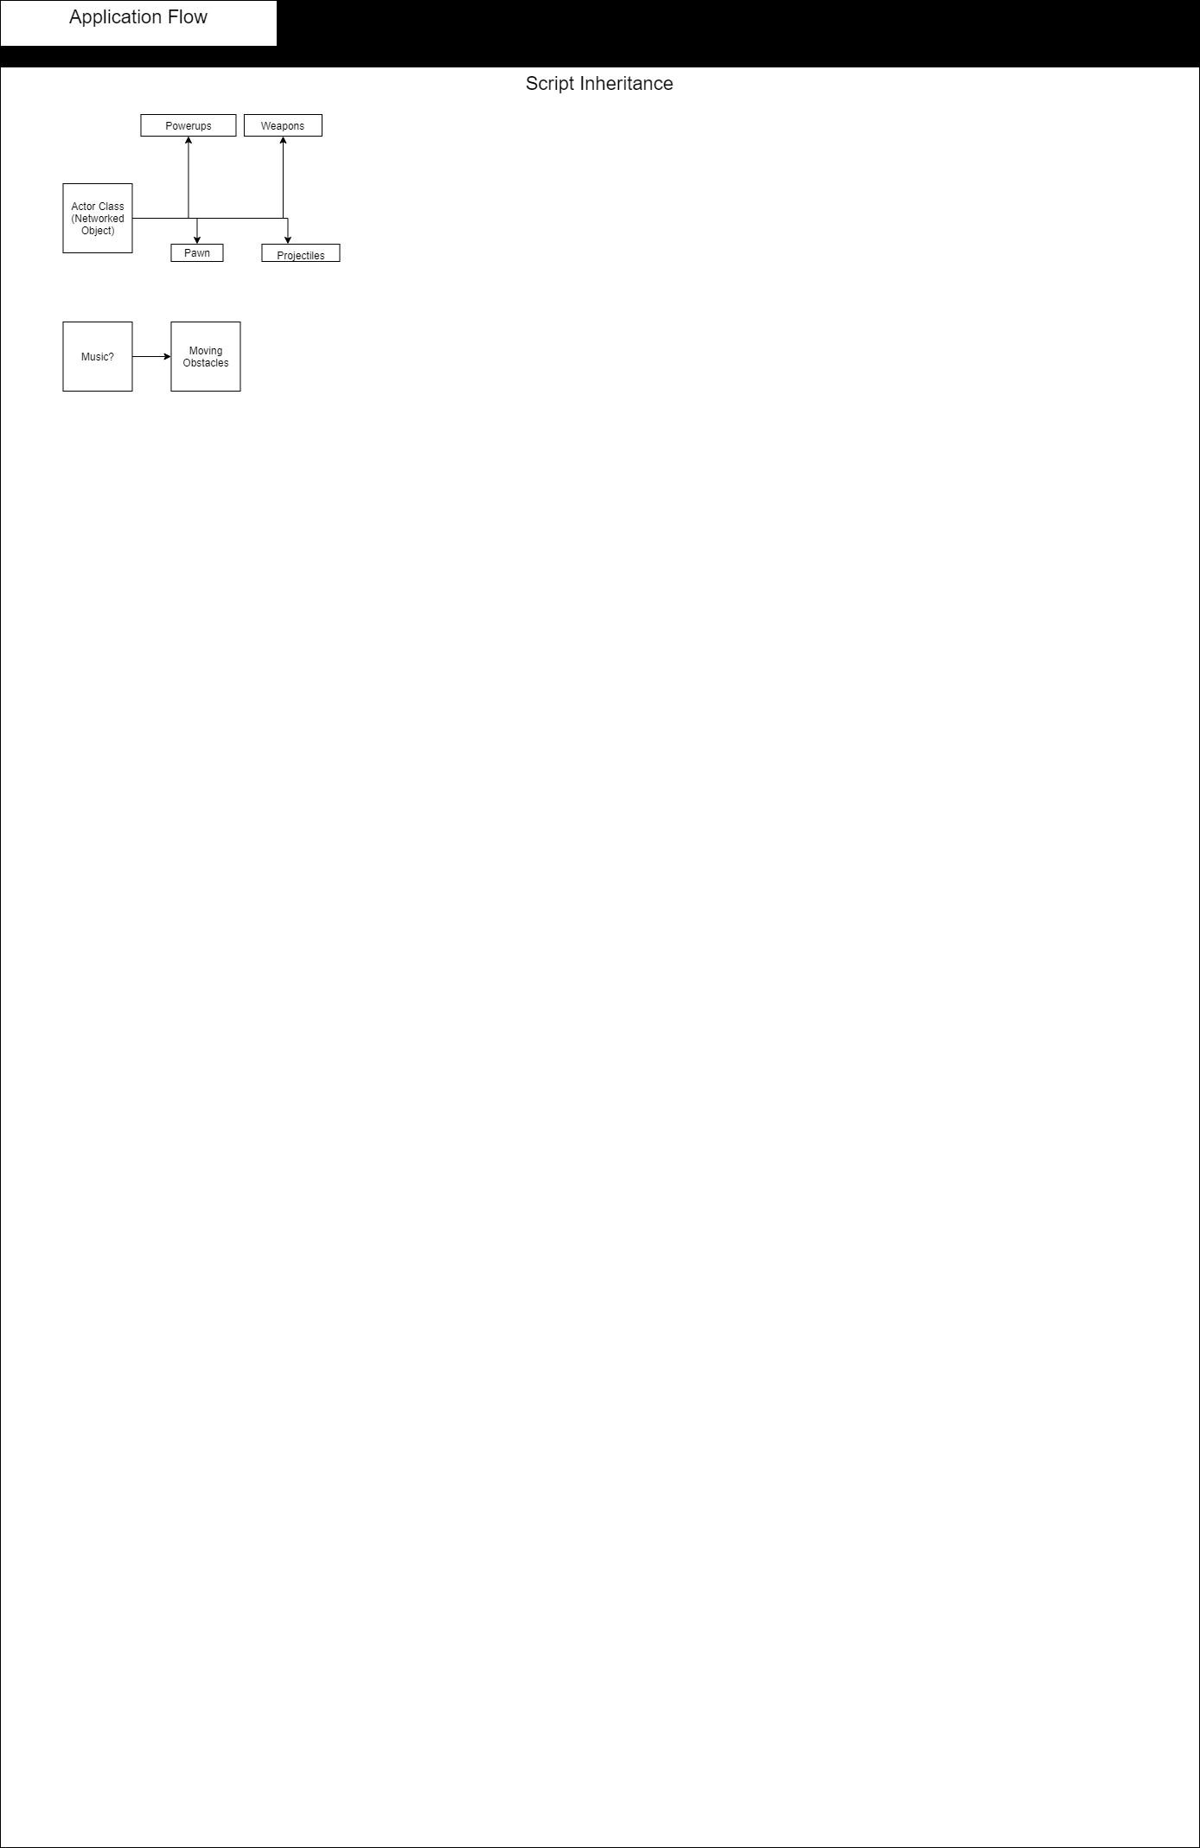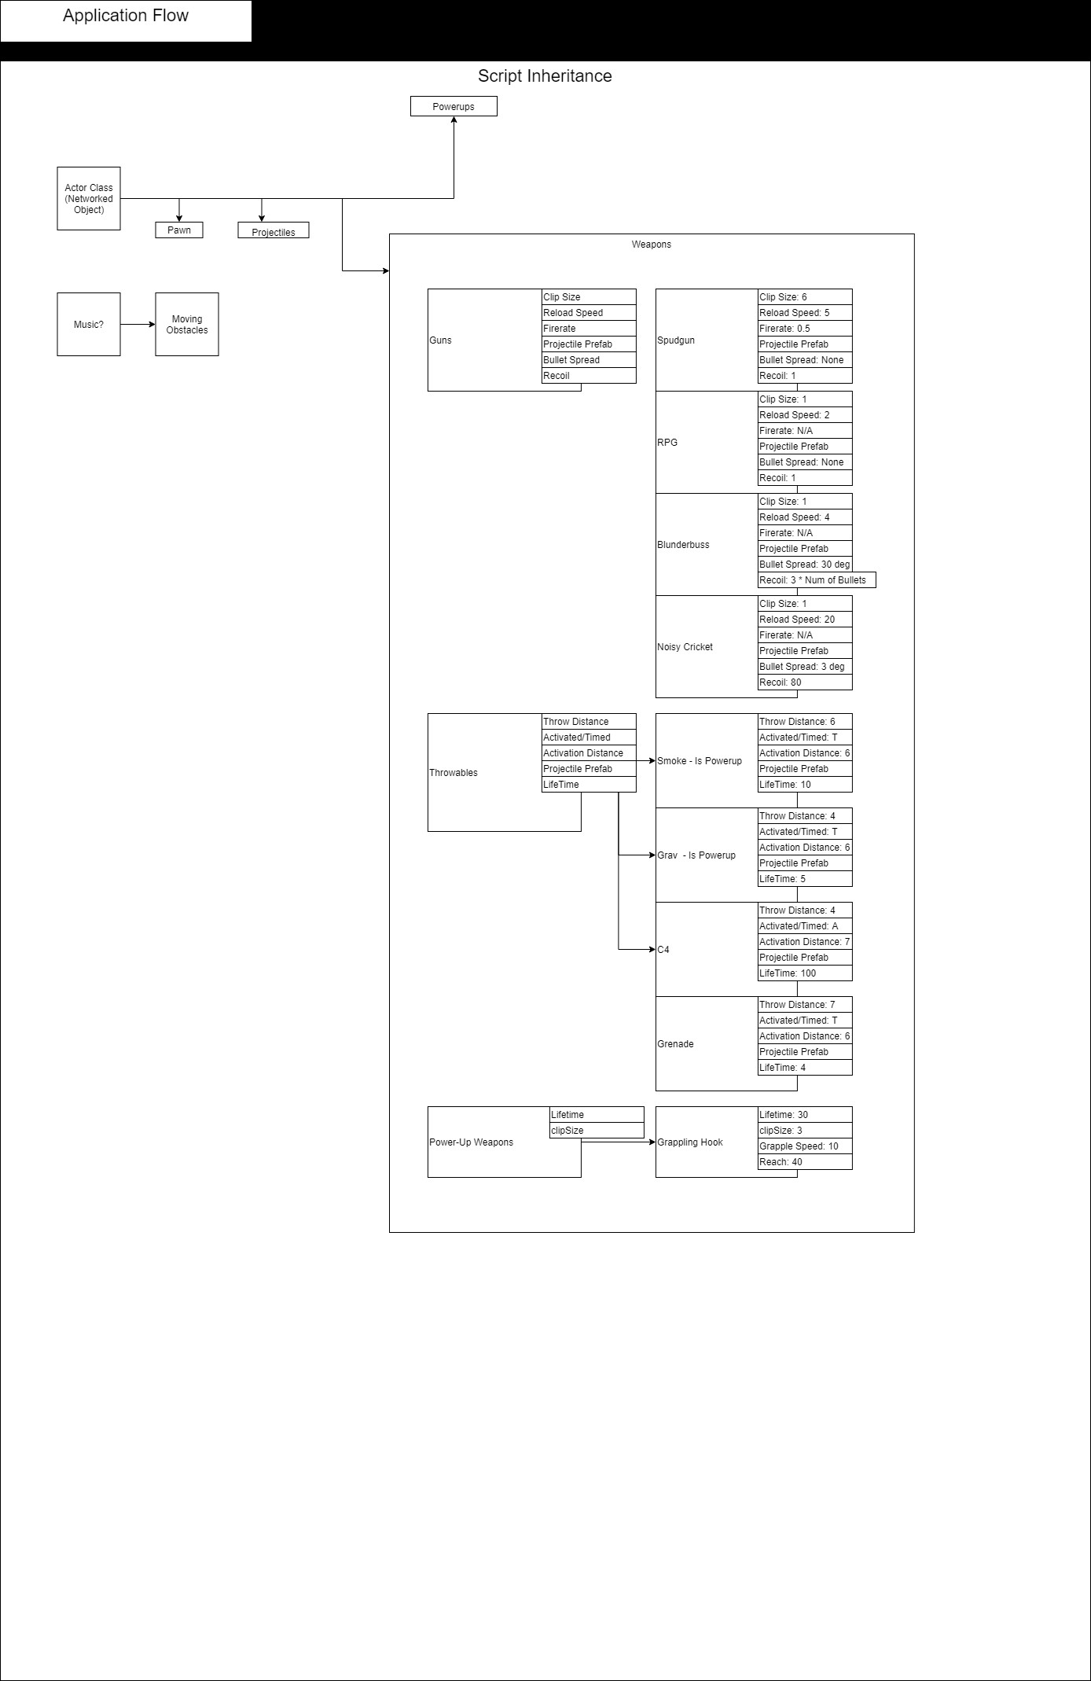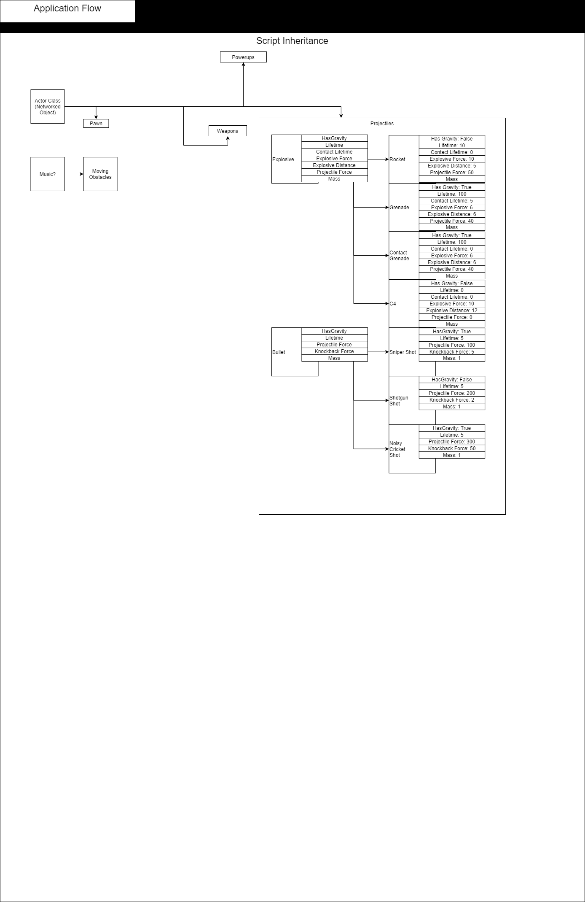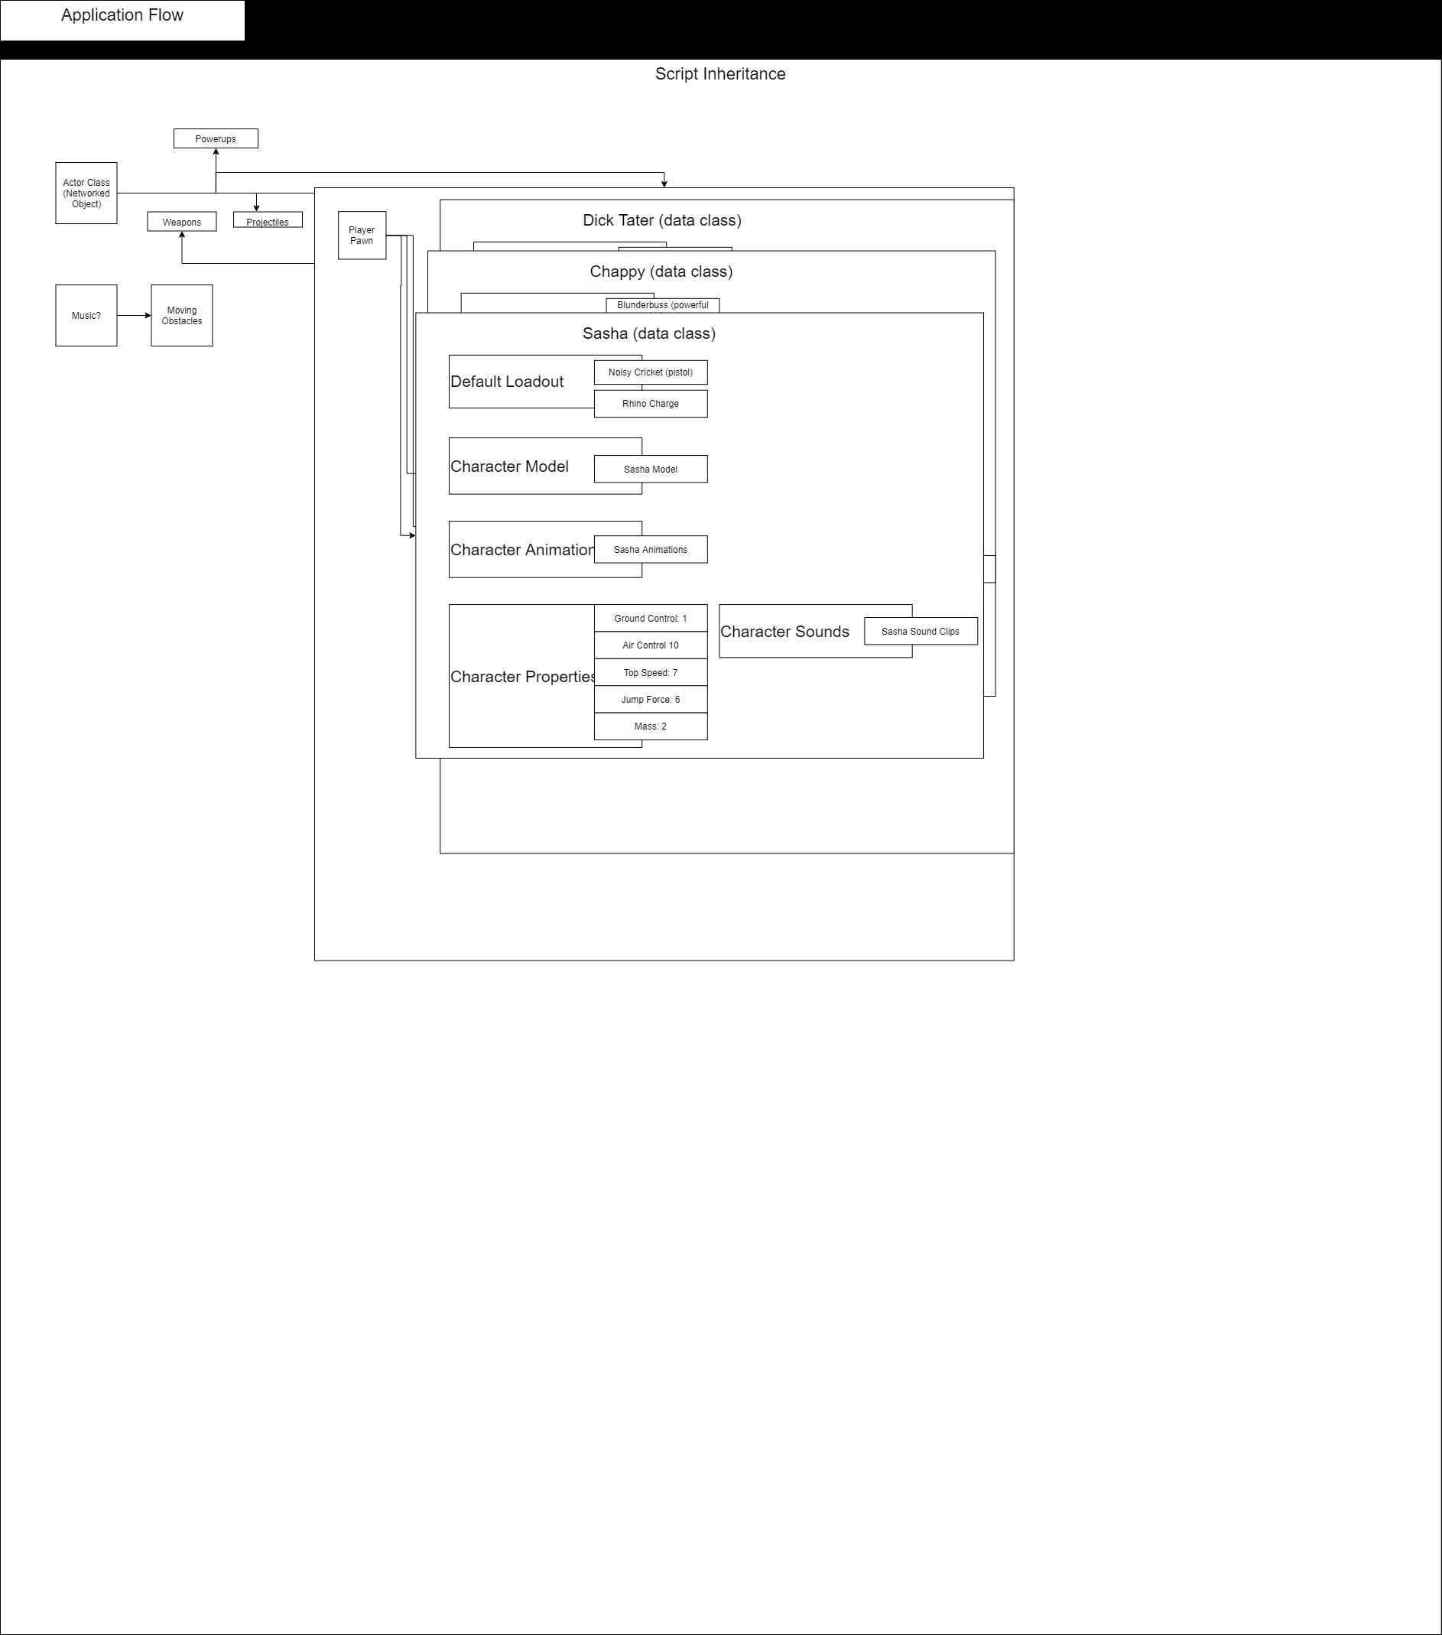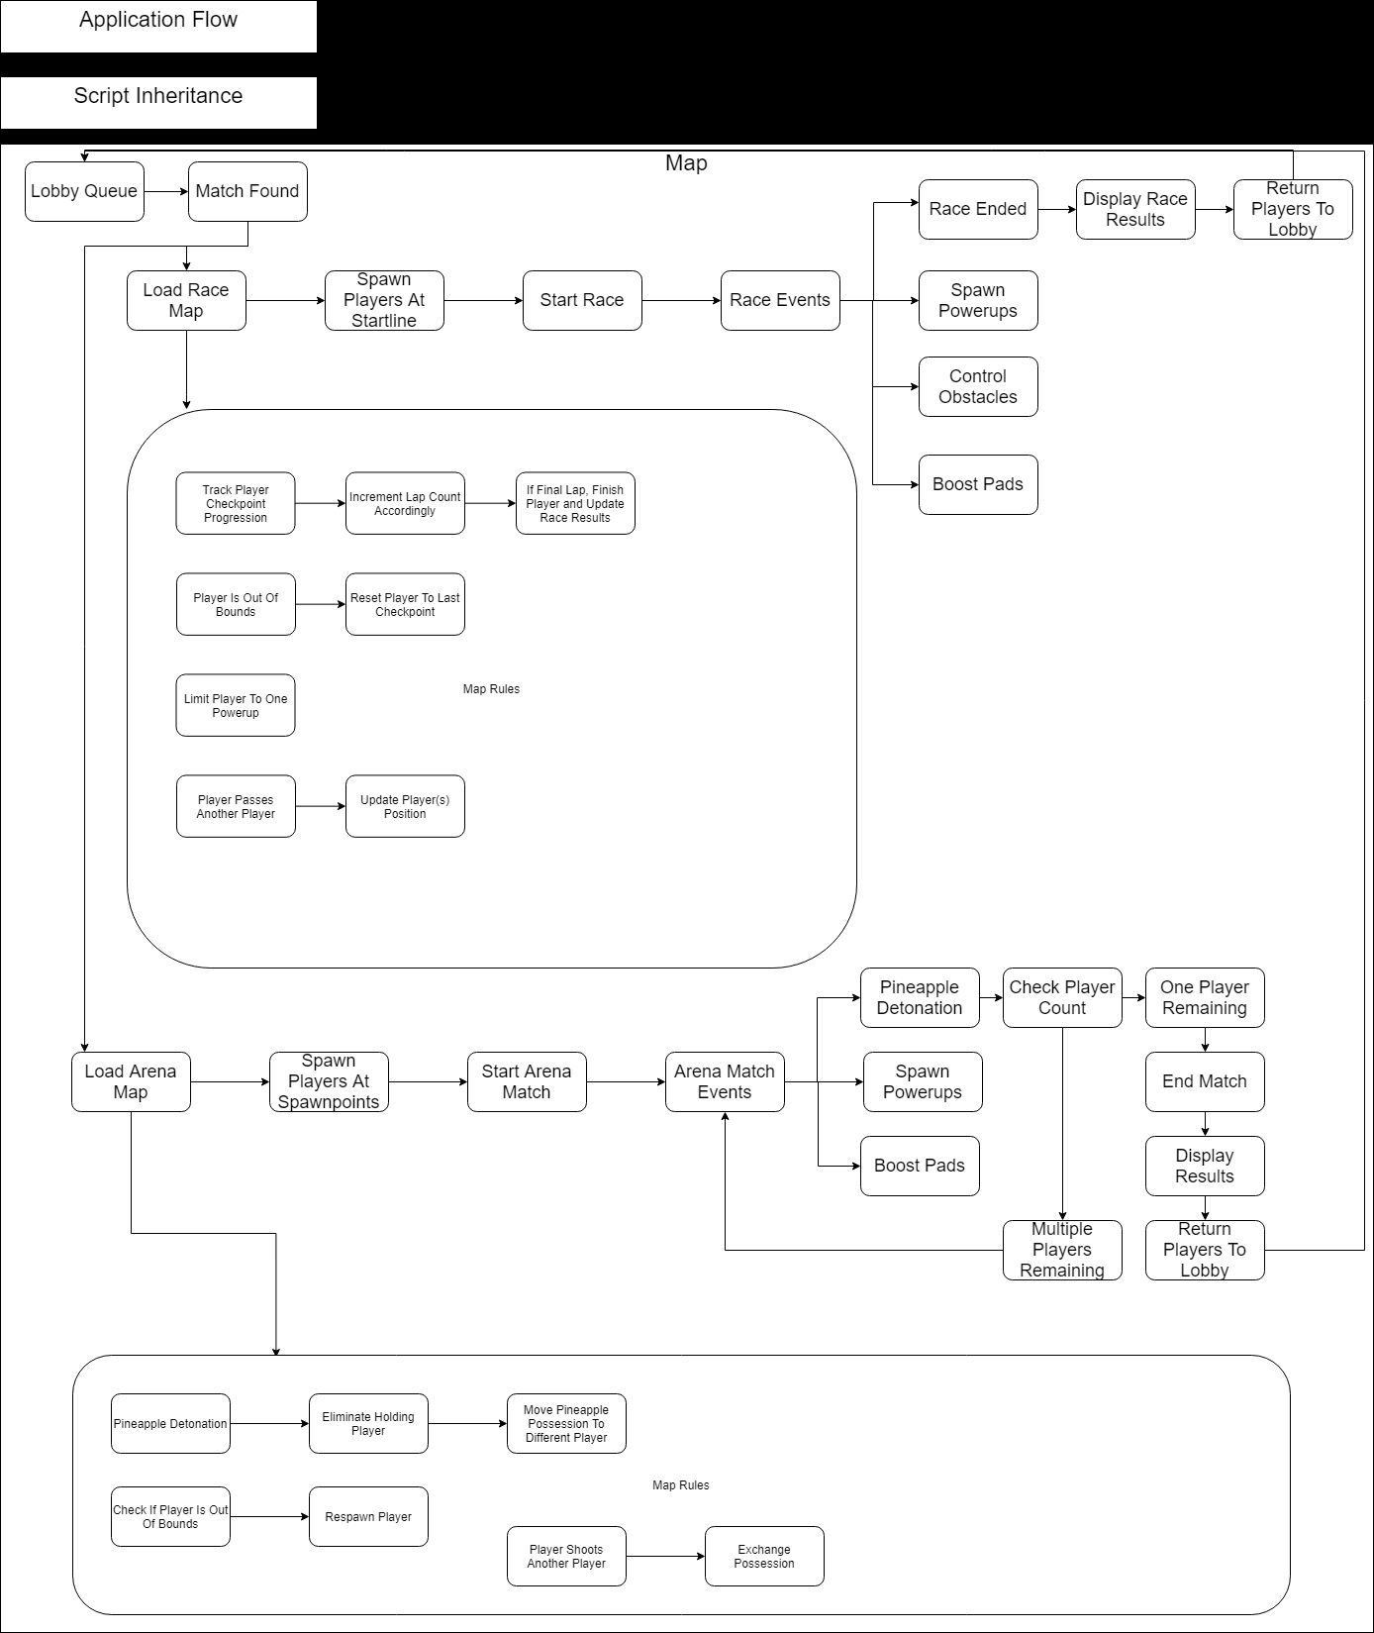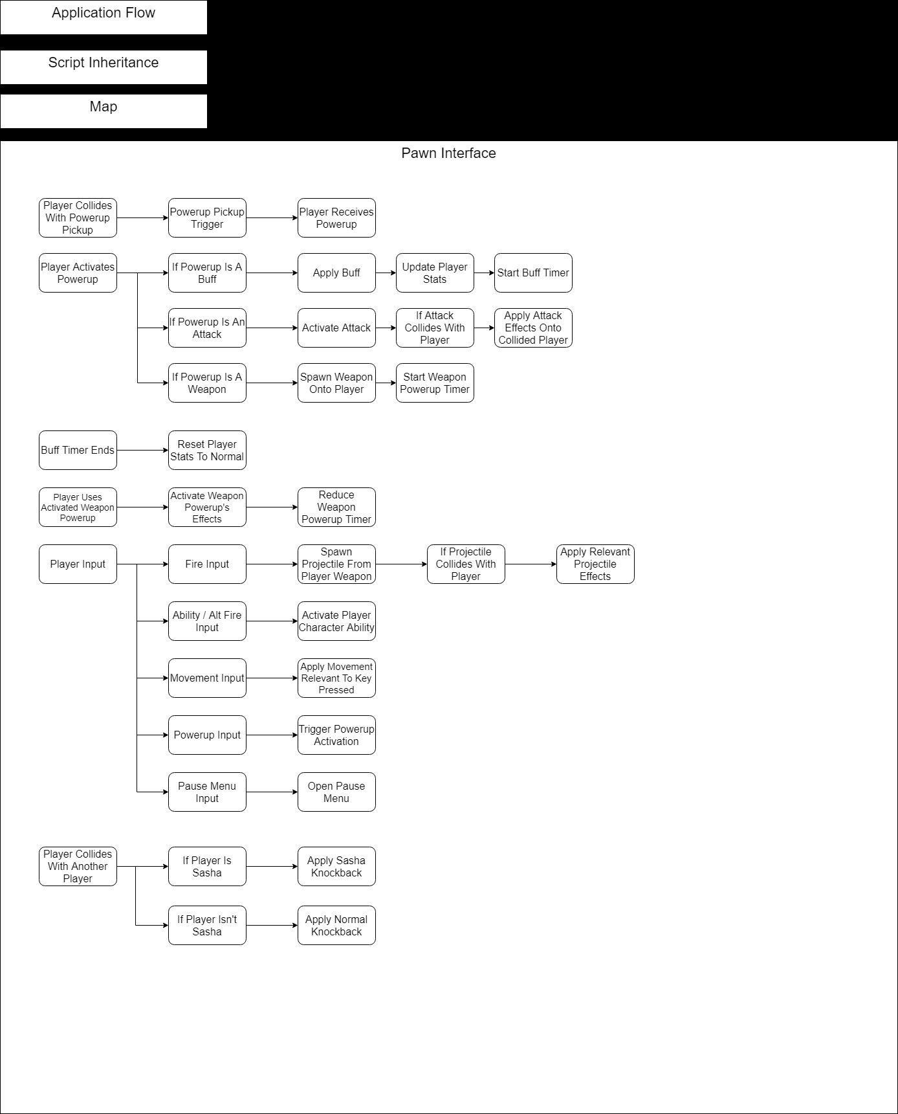

**4. Art Tools**

**Photoshop**

* CS6 or greater
* Graphics Editing program
* Allows User to manipulate or create images using a variety of tools
* Supports transparent Images
  + Useful for implementing small designs over other designs
* Used for creating textures
* Used for creating menu graphics

**Blender**

* Version 2.91 or greater
* Open source 3D content creation suite
  + Features include:33333
    - Character modelling
    - Animation
    - Rendering
* Used for character modelling and misc. Modelling

**5. 3D Objects, Terrain, & Scene Management**

* Race Track:
  + Track
  + Stands
  + Platforms
  + Finish Line
  + Boost Platforms
  + Power-up spawners
* Pineapple Payload
  + Arena
  + Stands
  + Platforms
  + Pineapple
  + Boost Pads
  + Power-up spawners

**6. Audio & Visual Effects**

* Royalty free sound effects from the internet
* Record/effects from Audacity